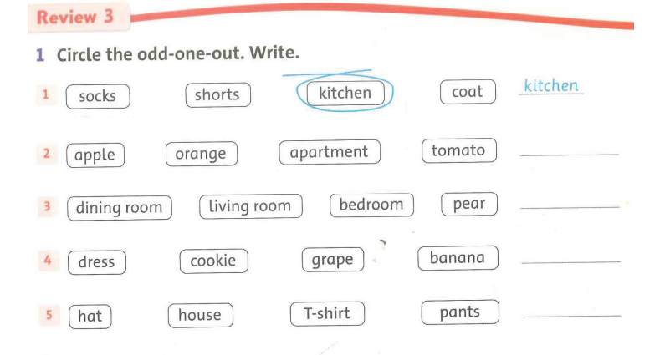
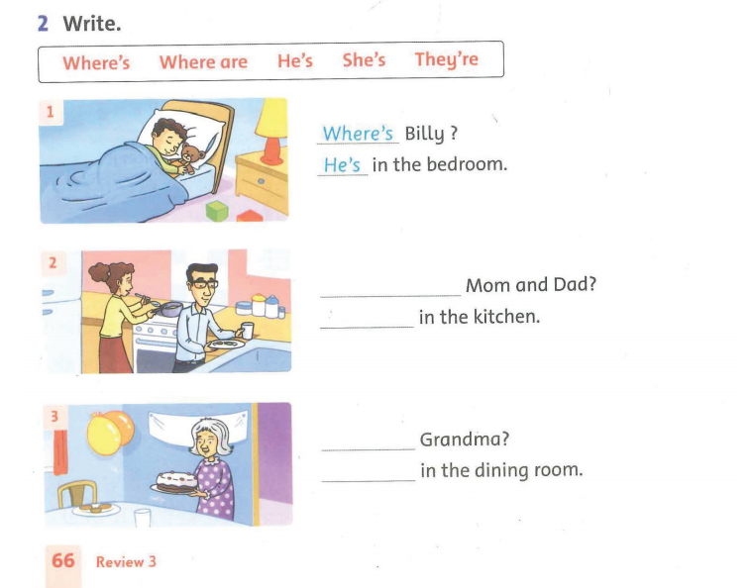
STUDENT BOOK ( page 66,67)- week 25
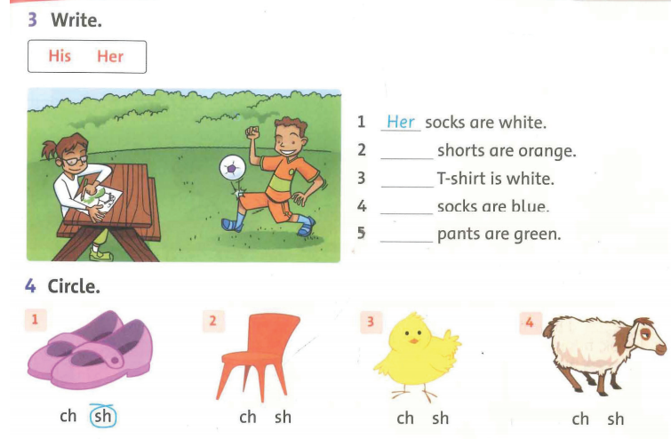
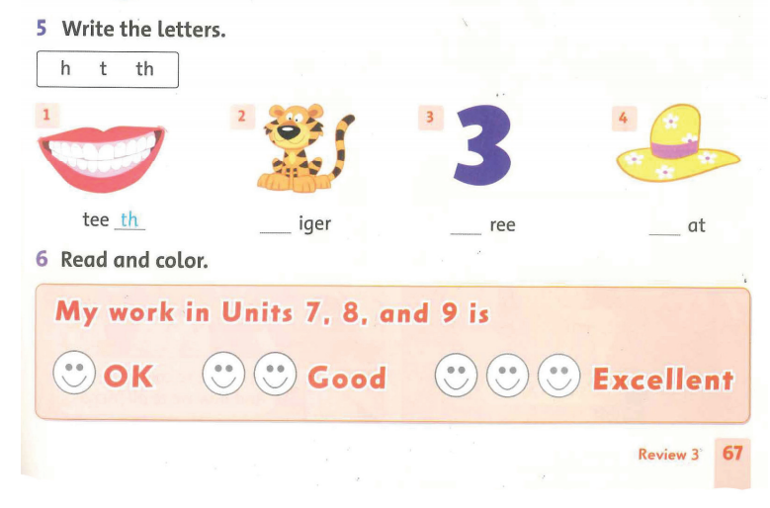

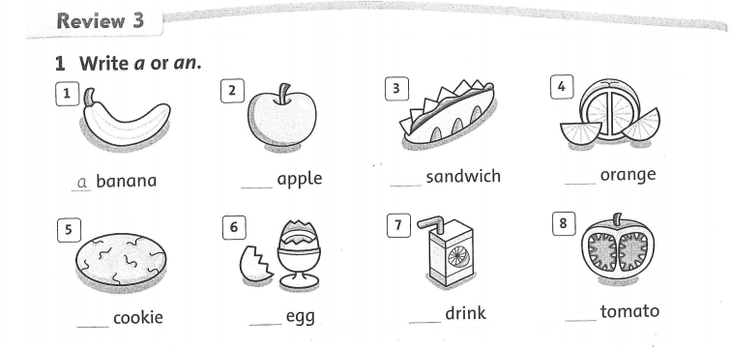
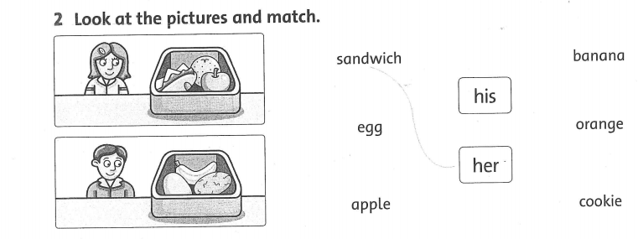
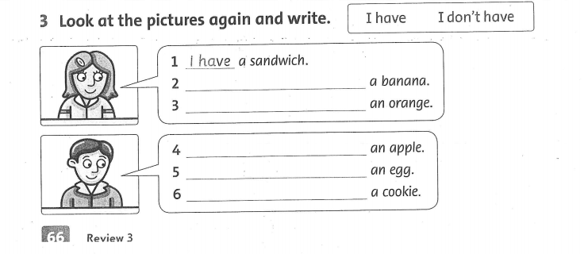
WORKBOOK ( page 66,67)

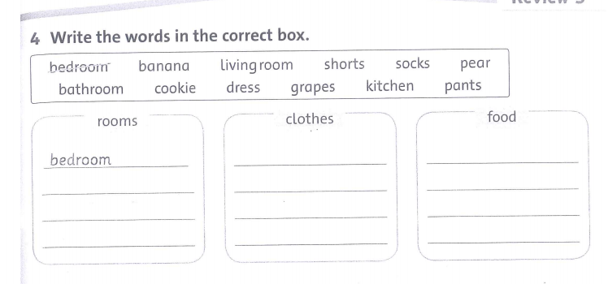
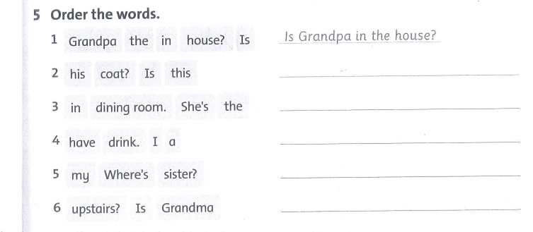
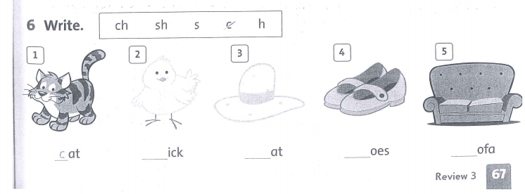

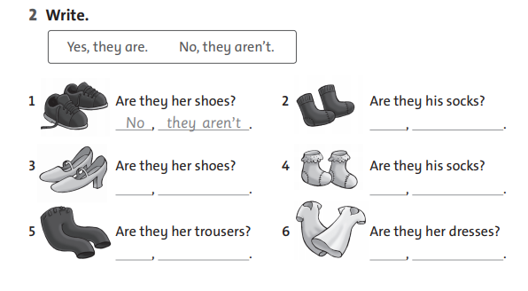
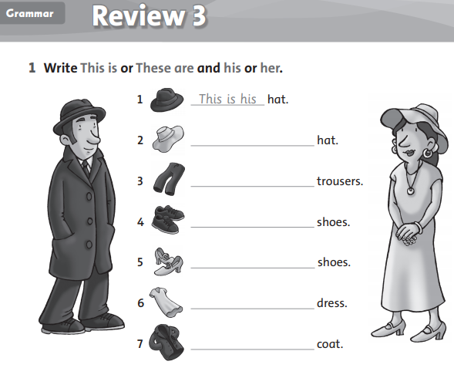

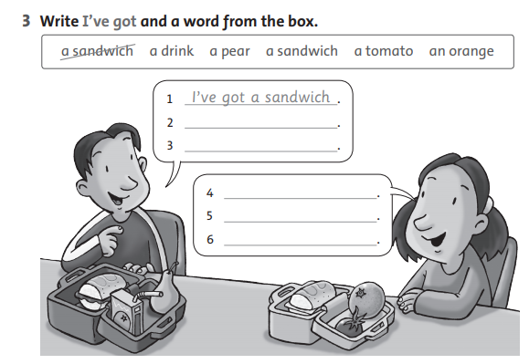
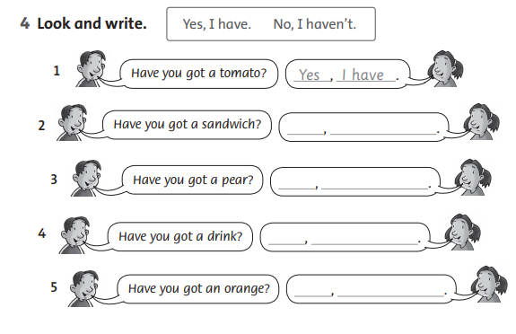

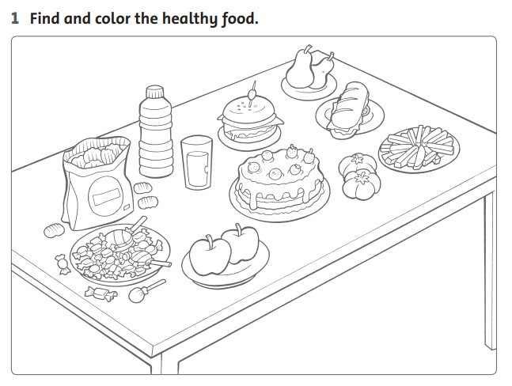
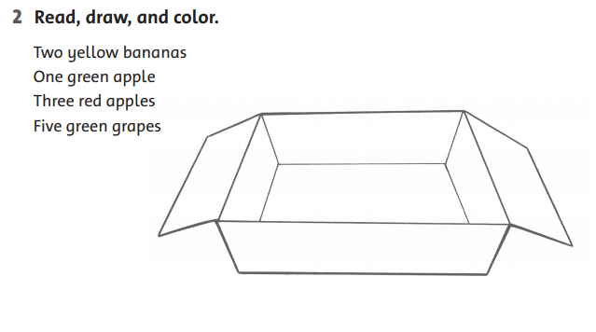
5.
6.

ĐÁP ÁN STUDENT BOOK

1. Circle the odd-one-out. Write.
2. apple / orange / apartment / tomato. __ apartment __
3. dining room / living room / bedroom / pear. __ pear ___
4. dress / cookies / grape / banana. __ dress ___
5. hat / house / T-shirt / pants. __ house ___
2. Write
1. where’s Billy/ He’s
2. Where are / They're
3. Where's / She's
3. Write
1. Her
2. His
3. Her
4. His
5. Her
4. Circle.
1. Shoes
2. chair
3. chicken
4. sheep
5. Write the letters.
1. teeth
2. tiger
3. three
4. hat

Đáp án WORKBOOK
1. Write a or an
1. a banana 5. a cookie
2. an apple 6. an egg
3. a sandwich 7. a drink
4. an orange 8. a tomato
2. Look at the pictures and match.
1. her sandwich her apple her orange
2. his banana his egg his cookie
3. Look at the picture again and write.
1. I have a sandwich.
2. I don’t have a banana.
3. I have an orange.
4. I don’t have an apple.
5. I have an egg.
6. I have a cookie.
4. Write the words in the correct box.
Rooms | clothes | food
Bedroom | Shorts | Pear
Living room | Socks | Cookie
Bathroom | Dress | Grapes
kitchen | Pants | banana
5. Order the words.
1. Is Grandpa in the house? 6. Is Grandma upstairs?
2. Is this his coat?
3. She’s in the dining room.
4. I have a drink.
5. Where’s my sister?
6. Write
1. cat 2. chick 3. hat 4. shoes 5. sofa

Đáp án Grammar review
1.write this is or these are and his or her
- This is his hat
- This is her hat
- These are his trousers
- These are his shoes
- These are her shoes
- This is her dress
- This is her coat
2. Write
- No, they aren’t
- Yes, they are
- Yes, they are
- No, they aren’t
- No, they aren’t
- Yes, they are
3. Write i ‘ve got and a word from the box
- I’ve got a sandwich
- I’ve got a pear
- I’ve got a drink
- I’ve got tomato
- I’ve got sandwich
- I’ve got an orange

4. Look and write
- Yes, I have
- Yes, I have
- No, I haven’t
- No, I haven’t
- Yes. I have
5.Find and color healthy food ( tìm và tô màu những món ăn tốt cho sức khỏe)
Read, draw and color ( đọc , vẽ và tô màu)
2 Trái chuối màu vàng
1 quả táo xanh
3 quả táo đỏ
5 trái nho xanh

